Lifetime odds of death for selected causes, United States, 2017
Cause of Death | Odds of Dying
Heart Disease | 1 in 6
Cancer | 1 in 7
Chronic Lower Respiratory Disease | 1 in 27
Suicide | 1 in 88
Opioid overdose | 1 in 96
Motor Vehicle Crash | 1 in 103
Fall | 1 in 114
Gun Assault | 1 in 285
Pedestrian Incident | 1 in 556
Motorcyclist | 1 in 858
Drowning | 1 in 1,117
Fire or Smoke | 1 in 1,474
Choking on Food | 1 in 2,696
Bicyclist | 1 in 4,047
Accidental Gun Discharge | 1 in 8,527
Sunstroke | 1 in 8,912
Electrocution, Radiation, Extreme Temperatures and Pressure | 1 in 15,638
Sharp objects | 1 in 28,000
Cataclysmic Storm | 1 in 31,394
Hot surfaces and substances | 1 in 46,045
Hornet, wasp and bee stings | 1 in 46,562
Dog attack | 1 in 115,111
Passenger on an airplane | 1 in 188,364
Lightning | 1 in 218,106
Railway passenger | 1 in 243,765

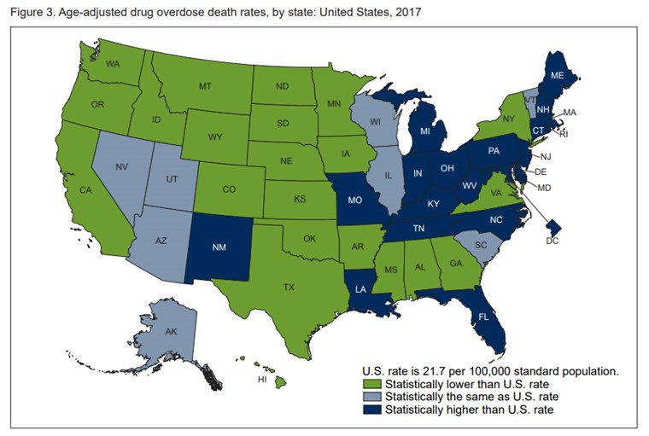

https://www.nbcnews.com/storyline/americas-heroin-epidemic/drug-overdose-deaths-top-70-000-drive-down-u-s-n941476

Resources
PRACTICAL TOOLKIT
Opioid Epidemic Practical Toolkit: Helping Faith and Community Leaders Bring Hope and Healing to Our Communities
This toolkit, developed by The Partnership Center, contains practical steps communities and congregations can take to bring hope and healing to the millions suffering the consequences of opioid use disorder.
Click here to download the toolkit. A two-page summary is attached.

RECORDINGS OF 2018 WEBINARS FEATURING FAITH AND COMMUNITY LEADERS
Throughout 2018, The Partnership Center hosted a series of national webinars featuring community-based innovative and promising practices and models addressing the opioid epidemic.

Opening Your Doors: Congregational Readiness and Recovery Support, Jan. 17, 2018.
Drew Brooks, Executive Director of Faith Partners, and Dale Ryan, co-founder of National Association for Christian Recovery, explored the practical concept of “congregational readiness” and what goes into starting a prevention or recovery support ministry or service in your community.

Increase Awareness: Creating a Culture of Compassion and Action in Response to the Opioid Epidemic, Feb. 21, 2018.
Kay Warren, cofounder of Saddleback Church, and Marla Kaufman, founder of the Jewish Addiction Awareness Network address the old conventions about addiction, fear, and misinformation that can challenge a community’s supportive response to these individuals and their families — often when they may need it most.

Opioid Epidemic: Strengthening Your Community’s Capacity to Connect to Vital Services and Support, March 28, 2018.
Monty Burks, Director Faith-based Initiatives, Tennessee Department of Mental Health and Substance Abuse Services, and Kevin Hoffman, Three Oaks Center, shared how communities and congregations are building their capacity to bring hope and healing to their communities.

Getting Back to Work: Employment, Recovery, and the Opioid Epidemic, May 16, 2018.
The nation’s Surgeon General VADM Jerome Adams, Chuck Collins, President and CEO of the YMCA of San Francisco, and Pastor Travis Lowe, of Crossroads Church, talked about the importance of health to the economy and how the recovery of individuals, and their families, is strengthened by gainful employment and self-sufficiency.

A Perfect Partnership: Faith & Community Response to the Opioid-related Crisis in Child Welfare
27, 2018. This webinar shared the latest HHS data related to substance misuse, the opioid epidemic, and the child welfare system. Community providers Brigid’s Path and The CALLshared their efforts to support NAS babies and their families as well as the foster care system in their communities.

Partnership Center’s Summer Webinar Series/The Science and Practice of Community-based Prevention of Substance Use. A three-part webinar series focused on the prevention of substance use.

· Brain Under Construction: Building Pathways to Resilient Futures, July 26, 2018.
Ruben Baler, PhD, NIDA health scientist, shared the latest science on the development of the brain
· ACEs: The Role of Life Experiences in Shaping Brain Development, August 9, 2018.
A one-hour training by public health experts in Tennessee on their curriculum Building Strong Brains: The Role of Life Experiences in Shaping Brain Development

· Prevention in Practice: Building Communities that Strengthen the Resiliency of Future Generations, August 15, 2018. Chicago’s Jewish Center for Addiction and the Georgia Prevention Project share strategies and the youth-led programs they are using to strengthen the resiliency of young people and prevent future generations from harm.

2017 HHS NATIONAL WEBINARS
In 2017, the Center hosted webinars featuring subject matter experts from HHS, including those from the CDC, NIDA, and SAMHSA, sharing timely information about the opioid epidemic, the brain science of addiction, treatment, the recovery process, prevention and pain management.
Do I Need this Pill? Understanding Pain and Prescription Drugs (Dec. 7)
Hope in Action: An Overview Of The Practical Toolkit For Faith And Community Leaders In The Face Of The Opioid Epidemic (Oct. 18).
There is Hope: Treatment, Recovery & Prevention (Aug. 16).
Understanding the Opioid Crisis: What’s at the Heart of the Matter? (Aug. 9).
HHS Live Stream of “Opioids: Recovery, Prevention & Hope, National Experts Equip Faith and Community Leaders” (Sept. 27).

ADDITIONAL INFORMATION & HANDOUT MATERIALS FROM THE U.S. DEPARTMENT OF HEALTH AND HUMAN SERVICES (HHS)

U.S. Department of Health and Human Services and the White House
Help, Resources and Information on the National Opioids Crisis
Opioids Crisis Next Door
Centers for Disease Control and Prevention (CDC)
Opioid Basics
Rx Awareness Campaign
Guideline for Prescribing Opioids for Chronic Pain Factsheet
Substance Abuse and Mental Health Services Administration (SAMHSA) Factsheets and Help-Lines
Managing Your Pain: Which Approach is Right for You?
What are the Risks of Opioid Medications?
What to do if Your Medication Isn’t Working?
Treating Overdose with Naloxone
SAMHSA’s Find Help & Treatment (Helplines and Resources)
National Institute on Drug Abuse (NIDA)
Teens: Drug Use and the Brain
Drugs, Brains, and Behavior: The Science of Addiction
Effective Treatments for Opioid Addiction
U.S. Surgeon General
Turn the Tide Campaign
Facing Addiction in America

ADDITIONAL COMMUNITY-BASED RESOURCES*
While the following is not a comprehensive survey of faith- and community-based recovery support programs and practices, we hope they provide a starting point for communities discerning the possibility of hosting these services.
Examples of Faith and Community-based Recovery Support Programs
· Faces & Voices of Recovery’s Guide to Mutual Aid Resources
· AA.org, NA.org Local Alcoholics Anonymous or Narcotics Anonymous Meetings.
· Al-Anon.org Local Al-Anon Meetings to support family members. Al-Anon.org
· Jewish Center for Addiction supports Chicago’s Jewish community with education, prevention and treatment resources.
· The Landing, Alateen Meetings or similar programs for young people.
· Celebrate Recovery (CR): A 12-step, Christian recovery program.
· Celebrate Recovery Inside (CRI): The prison and jail expression of Celebrate Recovery.
· Alcoholic Victorious: Meetings use 12 Steps, the Bible, & Alcoholics’ Victorious Creed.
· Overcomers Outreach: an international network of Christ-centered 12 Step support groups
· Phoenix Multisport: Sober Active Community: A sober-active recovery community that provides fitness programming to help foster the strengths necessary to maintain sobriety through physical pursuits and a sober network of friends.

Examples of National Networks, Resources, and Referrals to Local Programs
· Jewish Addiction Awareness Network (JAAN) JAANetwork.org
· Young People in Recovery YoungPeopleInRecovery.org
· Association of Recovery in Higher Education CollegiateRecovery.org
· National Association for Christian Recovery (NACR) NACR.org
· Buddhist Recovery Network BuddhistRecovery.org
· The Calix Society CalixSociety.org
· Jewish Alcoholics, Chemically Dependent Persons and Significant Others (JACS) http://bit.ly/2oM89vo

Examples of Faith Communities Shaped Around Recovery Support
· The Recovery Church, St. Paul, MI TheRecoverychurch.org
· Mercy Street, Houston, TX Chapelwood.org/Mercy-Street
· Congregation Minchas Yitzchok, Washington, D.C. GoDaven.com
· Northstar Community, Richmond, VA NorthstarCommunity.com
· Beit T’shuvah, Los Angeles, CA BeiTtshuvah.org

